5. The Full Report:

**• Illustrate or extend information from the initial draft**

**What is your topic and reason(s) to select this topic?**

**-To find out how covid-19 affects the travel rate in Thailand.**

As the pandemic has impacted the aviation industry as a whole and most of the major airports have been shut down, travel bans are being placed so people can’t travel frequently as they used to do before. Because of this, we want to find out how it impacted the Thailand tourism industry itself including figuring out if there are still plenty of people traveling to Thailand since it is one of the popular tourist areas or if there has been a reduction in visitors coming into the country. Thailand will be majorly impacted by the pandemic due to its tourist sector being the main provider of job opportunities, approximately 13-14% of the country economy. Since the outbreak in China, the country placing a travel ban has impacted Thailand a great deal due to a large proportion of Chinese, 30% in exact accounting to contribution of the tourism sector of the country.On April 3, curfew of 10pm to 4am was imposed which the emergency decree was extended until the 31st of May, starting from March 26. Suddenly, Bangkok temples and markets were visited less and less as well as the streets started becoming empty, people losing their jobs or those who are supposed to be working have been put on a wait list. Many people going out of Thailand especially foreign students who either have gone back or some of those who stay in the country cannot during further times go back to their own home country.

**-Since Thailand is one of the popular tourist destinations, we want to know how many people visit Thailand (every year).**

Thailand is known as the land of culture, natural environment, adventure, delectable foods, and companionable people. As it is a Buddhist nation it has around 40,000 Buddhist temples for travellers to sightsee and immerse themselves in the culture. Many tourists visit the Thai Ancient Temples to experience the generous and diverse architecture of these Temples. Since Thailand has a handful of festivals, the most important Thailand Lantern Festival which takes place in November tends to attract a lot of travellers. “During these festivals, lotus-shaped baskets are placed in the rivers, monks meditate, and lanterns float in the sky” (Johannessen). Thai food and accommodation are another reason for Thailand to be the most popular tourist destination. Foods ranging from Tom Yum Goong, Pad Thai, Som Tam to some hot and sour dishes to coconut milk, galangal are said to be delicious, diverse, and inexpensive. “Thailand does high-quality accommodation range from US$ 60 for a 3-star hotel to about US$ 300 for a posh, 5-star hotel” (Johannessen). The polite, warm, and social nature of Thai people is an additional reason why visitors are encouraged to return to Thailand. Beaches like Bang Saen in Chonburi, Jomtien Beach in Pattaya, Freedom Beach in Phuket, and Lamai in Koh Samuia, 147 national parks and natural reserves, water sports and scuba diving are very popular among the tourists.

**- It has a lot of statistical data to prove the evidence and actual facts.**

The relationship involving the aviation industry will contain detailed notes of the different in travel rate before and after covid-19. Looking at the insights of specific numbers can make us see the impact of Covid-19 on Thailand tourism industry and the gross domestic product of the country. Prior to the previous years, beginning with 2017 the number of tourist visits increased from 35.35 million to 38.28 million in 2018 and further to 39.80 in 2019. Thai authorities expressed that visitors from 2018 to 2019 increase was limited to 4.24% which does not meet the expectation. Other than receiving earnings from travelers visiting the country and then spending money on various stuff inside of Thailand, another way of earning revenue is from exports of the country goods or services which has been decreasing in recent years. The unstable situation has not been able to improve for the rightful time has not come as the ever increasing covid-19 cases has put a stop to an increase in tourist arrivals. After the spread of pandemic move from China to other countries, reaching Thailand as well, starting from February 2020, it has gotten worse. Tourist Arrivals dropped to 6,691 million in the first quarter of 2020, which is a big difference from Tourist Arrivals in the first quarter of 2019 being 10,795 million, a contrast of (-38.01 %). However the worst was to come in March, 2020, when 819,429 tourists arrived when just in last year March, 2019, the country has received 3,473,088 tourist arrivals (-76.41%). Further, moving onward it is expected that there will be less tourist arrivals and in the second quarter of 2020, according to the Ministry of Tourism and Sports, the official records of arrivals was zero. Although here and there we can see people still entering into Thailand, in any case the arrival numbers were still close to zero. In order to really make a significant statement, researching these statistical data will easily be of help to anyone who needs evidence to prove something they believe is true.

**Work plan or process to obtain the result (for example, what method, formula, idea, …)**

**-Gathering the data.**

Our first task as a group was to find a way to gather the data. We used both secondary material derived from the internet as well as primary material gathered through the use of a survey created on Microsoft Forms. The internet was used to narrow down the list of choices of most visited cities, we found that the results were abundant and slightly inconsistent. To get a more accurate result, we decided to find the most visited cities on average (mean). The survey was targeted towards students from Stamford International university because of the abundance of international students. Our target was to gather 30 responses at least, this will provide a more consistent and accurate result overall.

**-Presenting the results.**

Our data will be presented in the form of an infographic poster. The poster will be created using an online free tool called canva. The methods used to measure and digest the raw data are: Mean, Median, Mode and Skewness, to find the average, most common answers and probability respectively. The results of our findings will be represented by graphs and charts such as: Pie Charts, Line graphs, Scatter diagrams and Histograms. These graphs and charts allow us to appropriately represent the results of our findings.

**Specify your analysis and the result of each question**

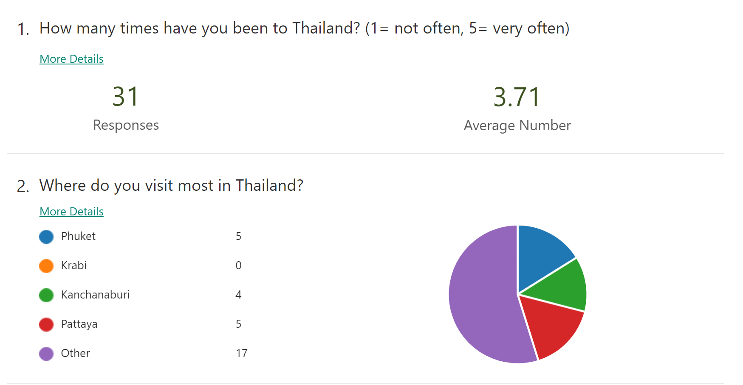

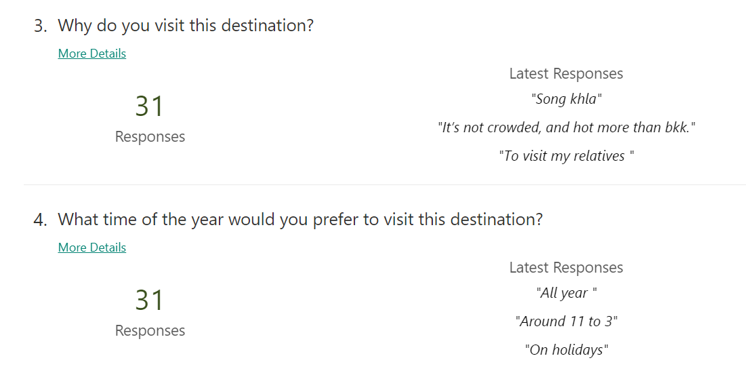

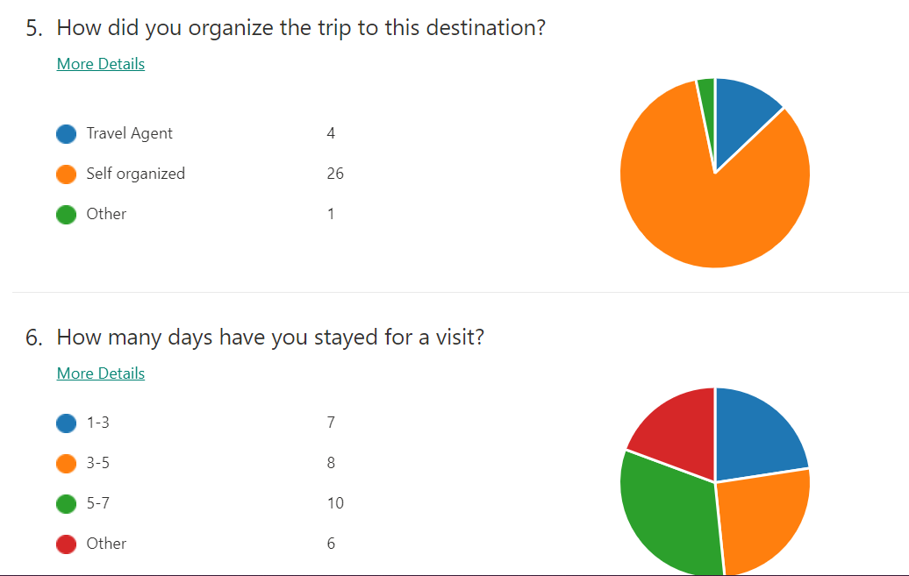

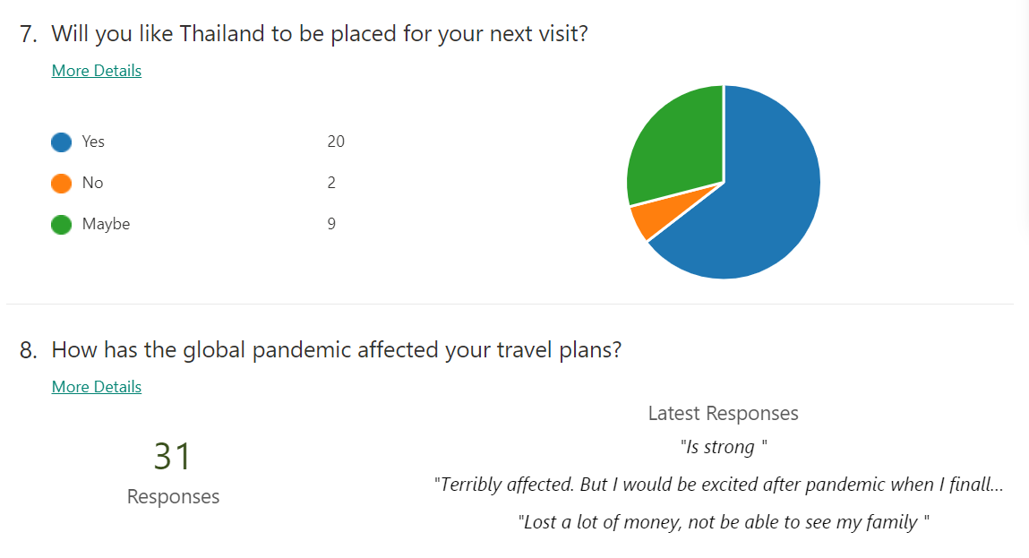

The survey had overall eight questions and 31 individuals responded to them.. The first question was a rating question from 1 to 5 scale, i.e. 5 choices, that asked how often or many times they have been to Thailand, where 1=not often and 5=very often and the mean average response was found to be 3.71 for the first. Second question had multiple choice questions with four options to choose that were asked where individuals visited the most in Thailand and Kanchanaburi had 4 responses, krabi-0, Phuket-5, Pattaya-5 and other-17, with “other” and “krabi” highest and lowest responses. The third question was the open-ended question. 31 individuals answered them freely in short sentences, some answers received from them, for instance-"To visit my relatives ","Song khla","It’s not crowded, and hot more than bkk.", etc*.* The fourth question was also open-ended that as the time of the year the people would visit, examples of answers were-"All year ", "Around 11 to 3" , "On holidays" and many more. The fifth question was a multiple-choice question that asked how they organised their trip to the destination, 26 individuals chose the option “Self-organised” which was the highest, the second lowest response was 4 for the option “Travel agent” and only 1 chose the option “other”. Since Thailand is one of the most popular tourist destinations, it is easier to plan a trip on our own. Booking a hotel online can provide many deals and going to different locations are made easier with the help of maps, e.g: Google maps. A lot of people voted for “self-organized” as it allows the travellers to have more freedom and gain better experiences. One of the main advantages of travelling with the help of a travel agency is that they have information about the rates and routes which saves our time and money. The sixth question asked for how many days they stayed during the trip. The highest number of responses received was 10 for the option “5-7”(days), the second highest was 8 responses for “3-5”, third highest was 7 for the option “1-3’ and 6 responded to “others” which was the lowest. The seventh question asked if Thailand should be placed for their next visit..Highest number of responses were 20 for the option “yes”, who would still like to visit Thailand other than regarding school activities. People are still going to be interested in visiting Thailand whether or not they have attended a school in the country, there are other aspects of traveling such as leisure travels, fun vacations, business matters and a lot of other activities in regards to people traveling to other places. There are still a lot of places to explore and discovers in Thailand and these students who came to Thailand for new environment and good education while during their term-breaks are giving the chance to properly look around the city of Bangkok and other areas as well which can benefit them in some way to be the tour guide to their families or friends or even to be able to give advice to strangers who need help with directions. Second highest responses were two for “Maybe” which they might felt confused and not have an answer for because they haven’t exactly gotten the chance to decide whether or not they enjoy staying in Thailand as the pandemic has impacted a lot of people lives and being unable to meet their families, hang out with friends and as they can’t go out that much either, they haven’t really have an opportunity to express how they feel staying in Thailand. Moving on, the lowest responses were 2 for “No”This might be due to personal reasons, preferences, their aspects on Thailand and involving many other factors we might not know which because of that they don’t generally “like to visit one country again if they stay too long there” or probably they just “miss home”. Finally, the last question asked about how the global pandemic affected their travel plans, the eighth question was the open-ended question. Some responses received were "Is strong ","Lost a lot of money, not being able to see my family " and "Terribly affected. But I would be excited after a pandemic when I finally could go on my trip" and many other comments.

**Problems during Project production**

Ideally, each member of our team would meet and communicate in person. This would make discussing and developing our topic as well as working on the actual project a lot easier and more efficient. Unfortunately that is not the case for our group. Due to the global pandemic that is currently going on in the world, our team members are separated in different countries, unable to meet and communicate in person. Our only method of communication was social media. Although it did the job, meeting in person would allow for a better, deeper discussion which might lead to an improvement in the overall project as well as better efficiency in the development phase of the project. At the same time, collecting responses for the survey from the students of Stamford University was not easy due to quarantine since we are studying online.We had to get responses by forwarding the survey link from friends to friends who study at Stamford and to multiple study groups of the current term courses on the social media app i.e the Line app. Not everyone in the group would fill up the survey forms for some common reasons ,for instance, they may find it uninteresting or maybe busy during our survey response collection process. However, we were able to collect responses over 30 in the end despite all the shortcomings.

**Conclusion from your topic**

In conclusion, “Tourist Destinations in Thailand” has a variety of aspects to it and among them has a lot of impact on how these destinations are visited or not visited by tourists as well as their own people. From investigation of this topic we have listed down and discovered how covid-19 has affected the travel rate in Thailand and how it has changed people traveling status before and after this pandemic, how much Thailand has loss the opportunity to earn revenues from travelers as well as import revenues by showing the statistical data which can be used as a proof to what we are saying.

Since coronavirus has put a great impact on the travel and tourism industry, the government has implied some restrictions for the travellers as a part of precautions. There are a lot of people who are stuck in some other countries restricting them from travelling back home. This has become one of the major problems as people are having to pay twice the money for the air ticket and also for the health insurance making it hard for them to afford. From our survey, we can conclude that a lot of students aren’t able to return back home and meet their families, and some had to cancel their travel plans.

Assumption that we made for ourselves might not be the same as what others are thinking on the topic at matter which leads us to forming a survey for Students from Stamford in order to see how people are feeling about the pandemic as well as the relations to these “tourist attractions destinations” that we listed down or that they could write down on their own if the one chosen by them is not in the survey. We gather the data which is crucial for later use in presenting what others have written down and also to be used in creating a poster.

We have extended our analysis, for it to be more specific and have a better understanding on how everyone else is feeling and even though some might have the same thinking, we can see that their wordings are differently put. The results of each questions are taking into account and our experience with doing this obviously will differ from other groups but in general, everyone might in doing this, will encounter problems due to various reasons, mainly because of the pandemic, we find a problem with not being able to meet each other and thoroughly discuss and work together in the same place but still this was a great opportunity to figure out new creative ways to connect with others.

With that being said, working on this helps us learn new things related to the topic at hand and to not take things for granted and especially because we are talking about the “tourist attractions” to not take traveling and being able to live or explore in other countries as something we can do easily. We as mentioned in “Contribution from our study” contribute our work to these major and minor industries, including people who have to leave their jobs, students who are struggling through hard times with their studies and also outside their student life’s, to elders who have passed away during these times, impacted by this pandemic and to everyone in general, in every country dealing with this situation.

**Contribution from your study**

Contribution from your study (to a community or to people or to an organization,..). For example, the result from this project will be an inspiration to save an environment …(The group does not need to submit raw data files. The full report should have at least 5 pages)

From our study we are contributing to those related to the tourism sector, aviation sector and service sector even though they are not directly related to our topic of “Tourist destinations in Thailand”, they contribute majorly in bringing people into a country and having make available the chance for diverse nationality and cultures to be brought together. Since the pandemic has severely impacted these industries and it is still not a good position for people to travel, these businesses have either been losing profits or are in a critical situation of having to shut down their jobs. This can lead to people losing jobs as the companies are not in the right state to pay with their operations not doing well and having to dismiss their employees. Also, for those who just graduated and are finding jobs out of the country or in their home country might have trouble getting one. In order to even visit Thailand tourist attractions places or generally speaking, to travel to other countries, these industries have to be up and running because if they are not, these places will have no visitors and if there are no visitors, there won’t be any improvements made in these areas in the first place. Moreover, these tourist attractions hold a great deal of money making as tourists spend on many things such as food, clothes, jewelry, shoes, bags, sports activities, amusement park, museums, etc, along the way of exploring the place itself. During these times, the country has less to earn from and the potential they have to make money off of these sites has reduced to a high amount. This could further lower the gross domestic product of the country, despite people buying many necessary products which in normal cases could increase the GDP, but on account of Covid-19 and recent political instability, anti-government protests, has heightened Thailand’s economic and market risks, in addition the country second quarter GDP has a sharp contraction by 12.2% year-on-year and 9.7% quarter-on-quarter, was the a noticeably excessive fall in GDP for Thailand since the Asian crisis in 1998. Besides that, the Covid-19 crisis has hit tourism and exports, leaving Thailand into recession. The country not only has no chance to earn money from tourist visits but also exports have been limited so that less revenues can be obtained from it. With the aviation industry missing in action on their parts have left a negative GDP growth and there is a possibility that it might still remain the same as the pandemic is still going all year round. It was stated according to ING, that Thailand’s rice exports fell 14% year on year in the first seven months of this year. The Thai Rice Exporters Association recently cut its export target by 13% to 6.5 million tonnes. In addition, our research includes contributions to peripatetic travelers who based their life on visiting various countries which because of this pandemic, they will have to put that on hold and are stuck in making home of a place for longer than they would expect. Also in general, for everyone who is going through this pandemic, working in another country, studying in other country than your own, or those who haven’t seen their families in a long time due to a variety of reasons, we contribute to these people who are going through this feeling depressed, unmotivated or even lacking the purposes in life, for them to know that we are facing this together. On the other hand, if talking about the positive side of this pandemic, the natural resources will be more beneficial for Thailand citizens since the government can focus on spending these natural resources for their people as well as preserving these tourist attraction sites as if too many people visit the place in a year, the place can experienced damages, too much waste, soil erosion, etc., which the government can improve during the pandemic in restoring and rebuilding these attractions sites so that when people visit again, it will be a much better experience to go through. Also, Thailand government is able to take this issue more seriously and into consideration in making their lands, streets, and buildings well recovered.